Name: Mohamed Ali Nawar Abd El Razeq

B.N/ 8

Date: 27/5/2020

Topic: Programming Languages

Github-link: <https://github.com/mohamed-ali2020/Programming_Languages-Rep>

**Application Brief:**

A program is a set of instructions given to a computer to perform a specific operation. or computer is a computational device which is used to process the data under the control of a computer program.While executing the program, raw data is processed into a desired output format. These computer programs are written in a programming language which are high level languages. High level languages are nearly human languages which are more complex then the computer understandable language which are called machine language, or low level language.So after knowing the basics, we are ready to create a very simple and basic program. Like we have different languages to communicate with each other, likewise, we have different languages like C, C++, C#, Java, python, etc to communicate with the computers. The computer only understands binary language (the language of 0’s and 1’s) also called machine-understandable language or low-level language but the programs we are going to write are in a high-level language which is almost similar to human language.

* Home Page

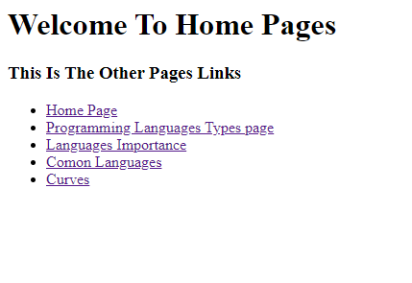

* Programming Languages Types

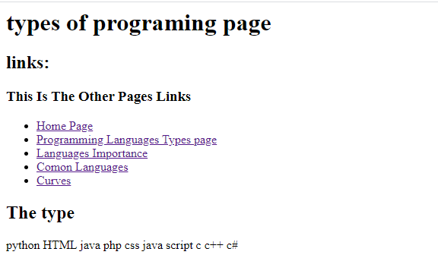

----------------------------------------------------------------------------------------------------

* Languages Importance

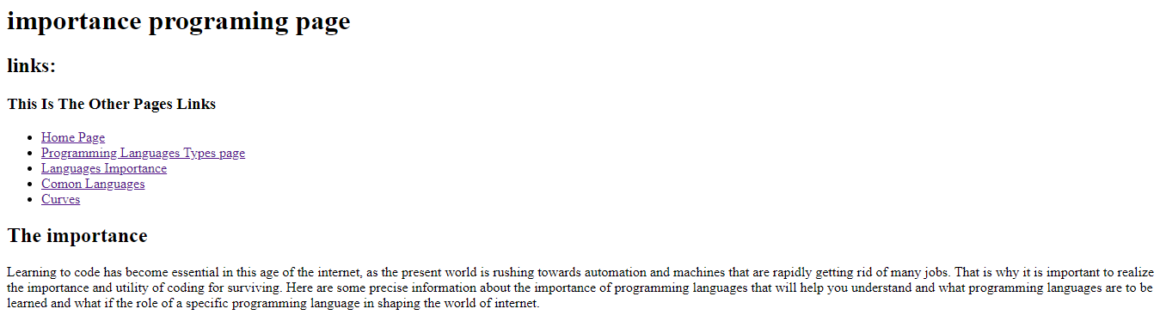

* Common Languages

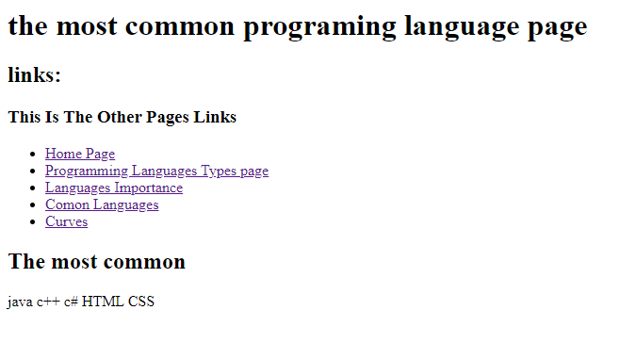

----------------------------------------------------------------------------------------------------

* Curves

